Competent authority responsible for ensuring compliance with Regulation (EC) No 1760/2000 title I is:

Ministry of Agriculture of the Czech Republic

Těšnov 17

117 05 Prague 1

Czech Republic

Contact person:

Mrs. Jitka Leiblová

Tel.: +420 221 814 579

e-mail: jitka.leiblova[@mze.gov.cz](mailto:machek@mze.cz)

Address for **returning** of the **passport** accordance with Article 6 point 4 of Regulation (EC) No 1760/2000

**Českomoravská společnost chovatelů, a.s.**

**Hradištko 123**

**252 09 Hradištko**

**Czech Republic**

THE MARKING OF BOVINE ANIMALS IN THE CZECH REPUBLIC

**Specimen of eartag used for bovine animal identification born before 1.5.2004.**

1. Specimens of plastic eartag – left ear

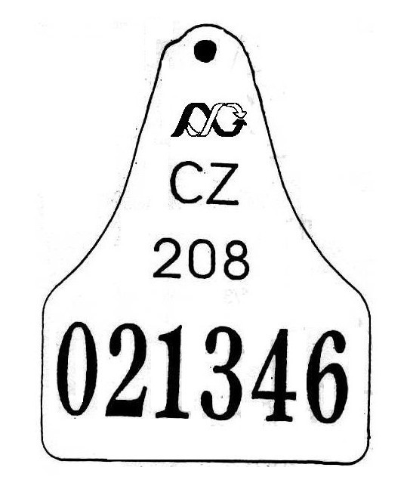or 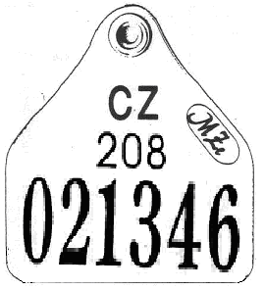

*logo*

*country code*

*district*

*series No*

plastic

1. Specimensof a eartag – right ear

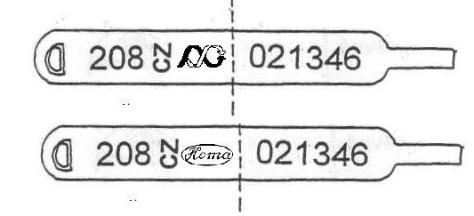

metal

or

metal

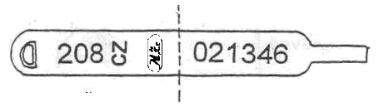

or



plastic

Before 1.1.2003 plastic eartag could be composed from one part, after this date it is made from two identical parts.

Note:

Animal identification number shown on the eartag shall be read in the following sequence „CZ 021346 208“.

Duplicates of these tags tagged before 1.5.2004 are marked with “**\***” or roman numeral.

**Specimen of plastic eartag used for bovine animal identification born since 1.5.2004.**

1. Specimen of plastic eartag - both ear



Note:

Animal identification number shown on the eartag shall be read in the following sequence „CZ 021346 208“.

 Logo of the competent authority according to regulation 1760/2000

1. Specimen of one part of duplicate of plastic eartag used for bovine animal identification with exception of the bovine animals moved from EU member states used after 1.5.2004

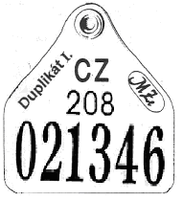

Note:

Animal identification number shown on the duplicate of eartag shall be read in the following sequence „CZ 021346 208“ apply to animals of Czech republic origin.

1. Specimen of duplicate of plastic eartag used for identification of bovine animal moved from EU member states (example: animal from Ireland with number “111111222222”)

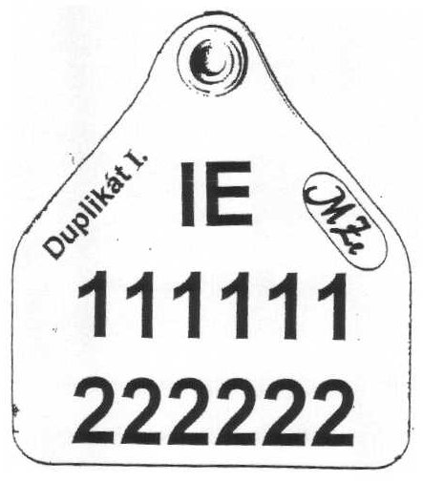

Note:

Animal identification number shown on the duplicate of plastic eartag shall be read in the following sequence „IE 111111222222“ apply to animals moved from EU member states.

##### 1.1. Model of the passport until 19.8.2001 - female

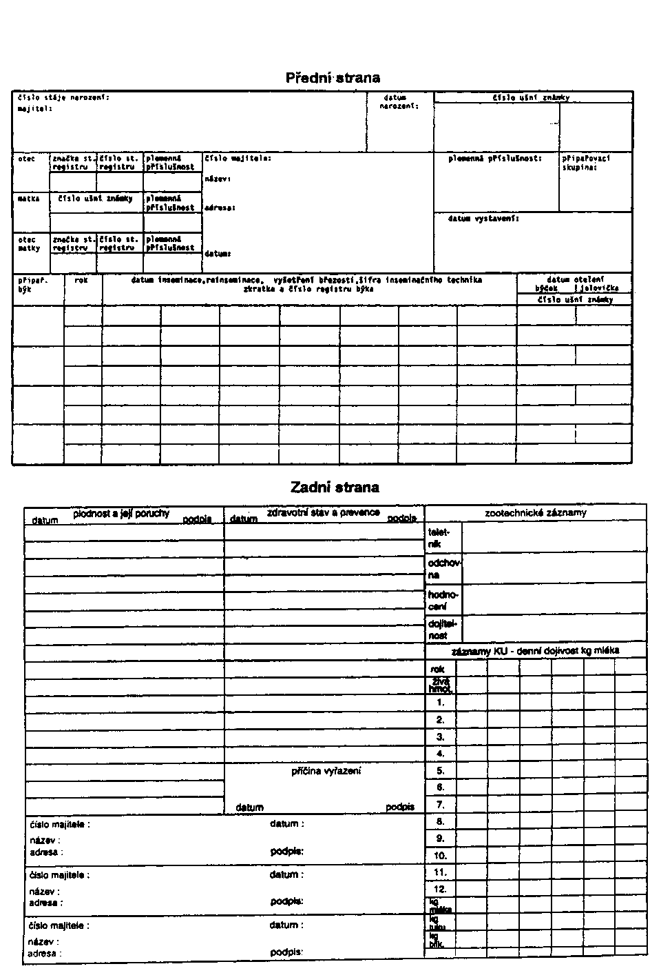

Front side

Reverse side

##### 1.2. Model of the passport until 19.8.2001 - male

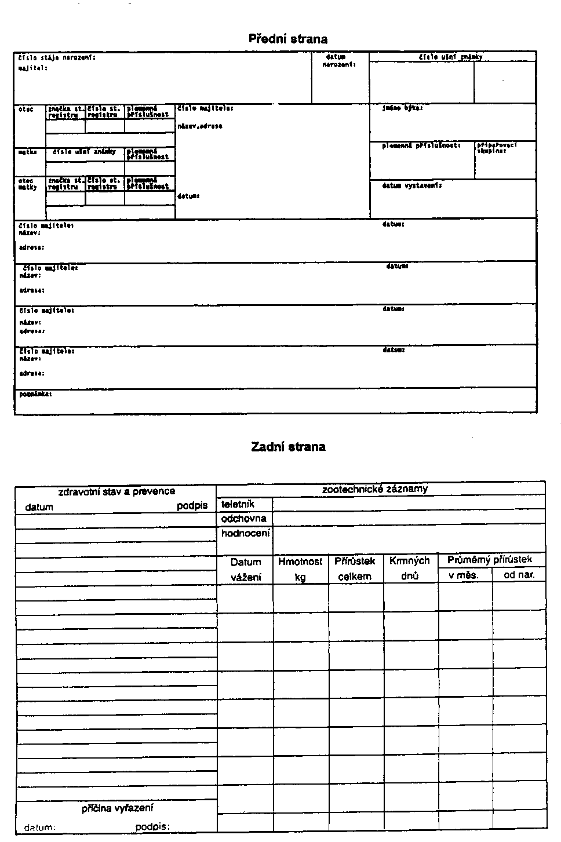

Front side

Reverse side

### 2. Model of the passport until 30.6.2004

**Front side**

|  |  |  |  |  |  |  |  |
| --- | --- | --- | --- | --- | --- | --- | --- |
| Ušní známka | | | | Narození | | | Pohlaví |
| Kód země | Identifikační číslo zvířete | | |
| Datum | **Registrační číslo hospodářství** | |
|  |  | |  |  |  | |  |
| Ušní známka matky | | | | plemeno | | Plemenná příslušnost zvířete | |
|  |  | |  |  | |  | |
| **Vystavil:** | |  | | | | **Dne:** |  |
| Poznámky: | | | | | | | |

**Reverse side**

|  |  |  |  |  |  |  |  |  |  |  |  |  |  |
| --- | --- | --- | --- | --- | --- | --- | --- | --- | --- | --- | --- | --- | --- |
| Přemisťování | | | | | | | | | | | | | |
| Datum | Registrační číslohospodářství, obchodníka, provozovny jatek, provozovny asanačního ústavu | | | | | | | | | | | | Podpis |
|  |  |  |  |  |  |  |  |  |  |  |  |  |  |
|  |  |  |  |  |  |  |  |  |  |  |  |  |  |
|  |  |  |  |  |  |  |  |  |  |  |  |  |  |
|  |  |  |  |  |  |  |  |  |  |  |  |  |  |
|  |  |  |  |  |  |  |  |  |  |  |  |  |  |
|  |  |  |  |  |  |  |  |  |  |  |  |  |  |
|  |  |  |  |  |  |  |  |  |  |  |  |  |  |
|  |  |  |  |  |  |  |  |  |  |  |  |  |  |
|  |  |  |  |  |  |  |  |  |  |  |  |  |  |
|  |  |  |  |  |  |  |  |  |  |  |  |  |  |

##### 3.a. Model of the passport after 1.4.2004, in Czech

(Model 2. of the passport could be issued until 30.6.2004)

**Front side**

|  |  |  |  |  |  |
| --- | --- | --- | --- | --- | --- |
| Ušní známka - Identifikační číslo zvířete | | Narození | | | Pohlaví |
| Kód země |  | Datum | Registrační číslo hospodářství | |
|  |  |  |  | |  |
| Ušní známka matky | | Plemenná příslušnost matky | | Plemenná příslušnost zvířete | |
|  |  |  | |  | |
| Otec | | Plemenná příslušnost otce | |
|  | |  | |
| Vystavil: | | | | Dne: | |
| Poznámky: | | | | | |

**Reverse side**

|  |  |  |  |  |  |  |  |  |  |  |  |  |
| --- | --- | --- | --- | --- | --- | --- | --- | --- | --- | --- | --- | --- |
| Přemisťování | | | | | | | | | | | | |
| Datum | | | Registrační číslohospodářství, obchodníka, provozovny jatek, provozovny asanačního podniku | | | | | | | | | Podpis |
|  |  |  | číslo |  |  |  |  |  |  |  |  |  |
| název |  | | | | | | | |
|  |  |  | číslo |  |  |  |  |  |  |  |  |  |
| název |  | | | | | | | |
|  |  |  | číslo |  |  |  |  |  |  |  |  |  |
| název |  | | | | | | | |
|  |  |  | číslo |  |  |  |  |  |  |  |  |  |
| název |  | | | | | | | |
|  |  |  | číslo |  |  |  |  |  |  |  |  |  |
| název |  | | | | | | | |
|  |  |  | číslo |  |  |  |  |  |  |  |  |  |
| název |  | | | | | | | |
|  |  |  | číslo |  |  |  |  |  |  |  |  |  |
| název |  | | | | | | | |
|  |  |  | číslo |  |  |  |  |  |  |  |  |  |
| název |  | | | | | | | |
|  |  |  | číslo |  |  |  |  |  |  |  |  |  |
| název |  | | | | | | | |

**3.b. Model of the passport after 1.4.2004, translation to English**

(Model 2. of the passport could be issued until 30.6.2004)

**Front** **side**

|  |  |  |  |  |  |
| --- | --- | --- | --- | --- | --- |
| Eartag – animal identification number | | Birth | | | Sex |
| Country code |  | Date | Holding registration number | |
|  |  |  |  | |  |
| Eartag of mother | | Breed of mother | | Breed of animal | |
|  |  |  | |  | |
| Father | | Breed of father | |
|  | |  | |
| Issued by: | | | | On: | |
| Notes: | | | | | |

Reverse side

|  |  |  |  |  |  |  |  |  |  |  |  |  |
| --- | --- | --- | --- | --- | --- | --- | --- | --- | --- | --- | --- | --- |
| Movements | | | | | | | | | | | | |
| Date | | | Registration numberof holding, dealer, plant of a slaughterhouse, plant of a rendering establishment | | | | | | | | | Signature |
|  |  |  | number |  |  |  |  |  |  |  |  |  |
| name |  | | | | | | | |
|  |  |  | number |  |  |  |  |  |  |  |  |  |
| name |  | | | | | | | |
|  |  |  | number |  |  |  |  |  |  |  |  |  |
| name |  | | | | | | | |
|  |  |  | number |  |  |  |  |  |  |  |  |  |
| name |  | | | | | | | |
|  |  |  | number |  |  |  |  |  |  |  |  |  |
| name |  | | | | | | | |
|  |  |  | number |  |  |  |  |  |  |  |  |  |
| name |  | | | | | | | |
|  |  |  | number |  |  |  |  |  |  |  |  |  |
| name |  | | | | | | | |
|  |  |  | number |  |  |  |  |  |  |  |  |  |
| name |  | | | | | | | |

**4.a. Model of a cattle passport of a calf under 28 days of age – in Czech**

|  |  |  |  |  |  |  |  |  |  |  |  |  |  |  |  |  |  |  |  |  |  |
| --- | --- | --- | --- | --- | --- | --- | --- | --- | --- | --- | --- | --- | --- | --- | --- | --- | --- | --- | --- | --- | --- |
| Průvodní list skotu-telete do 28 dnů věku | | | | | | | | | | | | | | | | | | | | | |
| Ušní známka - identifikační číslo | | | | | | | | | | | | | | | | Narození | | | | | |
| **Kód země** | |  | | | | | | | | | | | | | **Datum narození** | | | | **Registrační číslo hospodářství**  **(narození telete)** | |
| **Den** | | **Měsíc** | **Rok** |
|  |  |  |  |  |  |  |  |  |  | |  |  |  |  |  | |  |  |  | |
| Ušní známka matky - identifikační číslo | | | | | | | | | | | | | | | | Pohlaví | | | | | |
| **Kód země** | |  | | | | | | | | | | | | |  | | | | | |
|  |  |  |  |  |  |  |  |  |  | |  |  |  |  |
| Přemísťování | | | | | | | | | | | | | | | | | | | | | |
| **Číslo řádku** | | **Datum přemístění** | | | | | | | | **Registrační číslo (hospodářství, obchodníka, provozovny jatek, provozovny asanačního podniku)** | | | | | | | | | | Podpis | |
| **1** | |  | | | | | | | |  | | | | | | | | | |  | |
| **2** | |  | | | | | | | |  | | | | | | | | | |  | |
| **3** | |  | | | | | | | |  | | | | | | | | | |  | |

**4.b. Model of a cattle passport of a calf under 28 days of age - translation to English**

|  |  |  |  |  |  |  |  |  |  |  |  |  |  |  |  |  |  |  |  |  |
| --- | --- | --- | --- | --- | --- | --- | --- | --- | --- | --- | --- | --- | --- | --- | --- | --- | --- | --- | --- | --- |
| Cattle passport of a calf under 28 days of age | | | | | | | | | | | | | | | | | | | | |
| Eartag – identification number | | | | | | | | | | | | | | | | Birth | | | | |
| **Country code** | |  | | | | | | | | | | | | | | **Date of birth** | | | **Registration number of the holding**  **(of the calves birth)** | |
| **Day** | **Month** | **Year** |
|  |  |  | |  |  |  |  |  |  |  | |  |  |  |  |  |  |  |  | |
| Eartag of mother – identification number | | | | | | | | | | | | | | | | Sex | | | | |
| **Country code** | |  | | | | | | | | | | | | | |  | | | | |
|  |  |  | |  |  |  |  |  |  |  | |  |  |  |  |
| Movements | | | | | | | | | | | | | | | | | | | | |
| **Line number** | | | **Date of movement** | | | | | | | | **Registration number (of holding, dealer, slaughterhouse plant, rendering plant)** | | | | | | | | | Signature |
| **1** | | |  | | | | | | | |  | | | | | | | | |  |
| **2** | | |  | | | | | | | |  | | | | | | | | |  |
| **3** | | |  | | | | | | | |  | | | | | | | | |  |

**Breed codes:**

A Ayrshire

B Belgian Blue

C Czech Fleckvieh

D Salers

E Highland

F Brahman

G Aberdeen Angus

H Holstein Cattle

I Montbeliarde

J Jersey

L Bohemian Red Cattle Breed

M Red Pied Cattle

N Normand Breed

P Piemontese

Q Blonde d´Aquitaine

R Red Holstein

S Gasconne

SM Simmental Beef Cattle

T Charolais

U Hereford

V Braunvieh

W Galloway

Y Limousine

X not registered breeds (only 19 breeds have its own register) or unknown breeds

Z not registered breeds (other beef breeds)

X and Z are similar for use, previously we had only X for dairy and beef not registered breeds, nowadays we try to separate population into dairy - X and beef - Z population of not registered breeds or unknown breeds.

Holding register

Left side

|  |  |  |  |  |  |  |  |  |  |  |  |  |  |  |  |  |  |  |  |  |  |  |  |  |  |  |  |  |  |  |  |  |  |  |  |  |
| --- | --- | --- | --- | --- | --- | --- | --- | --- | --- | --- | --- | --- | --- | --- | --- | --- | --- | --- | --- | --- | --- | --- | --- | --- | --- | --- | --- | --- | --- | --- | --- | --- | --- | --- | --- | --- |
|  | Pořadové číslo listu | | | | | | | |  | | | | | |  | | | | | | | | | | | | | | | | | | | | | |
|  | | | | | | | | | | | | | | | | | | | | | | |  | | | | | | | | | | | | |
| **Č. řádku** | | **Ušní známka - identifikační číslo zvířete** | | | | | | | | | | | | | | | | **Přemístění-příchod zvířete1)** | | | | | | | | | | | | | | | | **Pohlaví** | **Plemeno nebo barva** | |
| **Kód země** | |  | | | | | | | | | | | | | | Datum | | | | | | **Registrační číslo (hospodářství, obchodníka)** | | | | | | | | **Označ. stáje** | |
| den | | měsíc | | rok | |
| **01** | |  |  |  |  |  |  |  | |  |  |  |  |  | |  |  |  |  |  |  |  |  |  |  |  |  |  |  |  |  |  |  |  |  | |
| **Datum narození zvířete:** | | | | | | | | | | | | | | | |  |  |  |  |  |  | **Pozn.:** | | | | | | | | | | | | |
| **02** | |  |  |  |  |  |  |  | |  |  |  |  |  | |  |  |  |  |  |  |  |  |  |  |  |  |  |  |  |  |  |  |  |  | |
| **Datum narození zvířete:** | | | | | | | | | | | | | | | |  |  |  |  |  |  | **Pozn.:** | | | | | | | | | | | | |
| **03** | |  |  |  |  |  |  |  | |  |  |  |  |  | |  |  |  |  |  |  |  |  |  |  |  |  |  |  |  |  |  |  |  |  | |
| **Datum narození zvířete:** | | | | | | | | | | | | | | | |  |  |  |  |  |  | **Pozn.:** | | | | | | | | | | | | |
| **04** | |  |  |  |  |  |  |  | |  |  |  |  |  | |  |  |  |  |  |  |  |  |  |  |  |  |  |  |  |  |  |  |  |  | |
| **Datum narození zvířete:** | | | | | | | | | | | | | | | |  |  |  |  |  |  | **Pozn.:** | | | | | | | | | | | | |
| **05** | |  |  |  |  |  |  |  | |  |  |  |  |  | |  |  |  |  |  |  |  |  |  |  |  |  |  |  |  |  |  |  |  |  | |
| **Datum narození zvířete:** | | | | | | | | | | | | | | | |  |  |  |  |  |  | **Pozn.:** | | | | | | | | | | | | |
| **06** | |  |  |  |  |  |  |  | |  |  |  |  |  | |  |  |  |  |  |  |  |  |  |  |  |  |  |  |  |  |  |  |  |  | |
| **Datum narození zvířete:** | | | | | | | | | | | | | | | |  |  |  |  |  |  | **Pozn.:** | | | | | | | | | | | | |
| **07** | |  |  |  |  |  |  |  | |  |  |  |  |  | |  |  |  |  |  |  |  |  |  |  |  |  |  |  |  |  |  |  |  |  | |
| **Datum narození zvířete:** | | | | | | | | | | | | | | | |  |  |  |  |  |  | **Pozn.:** | | | | | | | | | | | | |
| **08** | |  |  |  |  |  |  |  | |  |  |  |  |  | |  |  |  |  |  |  |  |  |  |  |  |  |  |  |  |  |  |  |  |  | |
| **Datum narození zvířete:** | | | | | | | | | | | | | | | |  |  |  |  |  |  | **Pozn.:** | | | | | | | | | | | | |
| **09** | |  |  |  |  |  |  |  | |  |  |  |  |  | |  |  |  |  |  |  |  |  |  |  |  |  |  |  |  |  |  |  |  |  | |
| **Datum narození zvířete:** | | | | | | | | | | | | | | | |  |  |  |  |  |  | **Pozn.:** | | | | | | | | | | | | |
| **10** | |  |  |  |  |  |  |  | |  |  |  |  |  | |  |  |  |  |  |  |  |  |  |  |  |  |  |  |  |  |  |  |  |  | |
| **Datum narození zvířete:** | | | | | | | | | | | | | | | |  |  |  |  |  |  | **Pozn.:** | | | | | | | | | | | | |
| **11** | |  |  |  |  |  |  |  | |  |  |  |  |  | |  |  |  |  |  |  |  |  |  |  |  |  |  |  |  |  |  |  |  |  | |
| **Datum narození zvířete:** | | | | | | | | | | | | | | | |  |  |  |  |  |  | **Pozn.:** | | | | | | | | | | | | |
| **12** | |  |  |  |  |  |  |  | |  |  |  |  |  | |  |  |  |  |  |  |  |  |  |  |  |  |  |  |  |  |  |  |  |  | |
| **Datum narození zvířete:** | | | | | | | | | | | | | | | |  |  |  |  |  |  | **Pozn.:** | | | | | | | | | | | | |
| **13** | |  |  |  |  |  |  |  | |  |  |  |  |  | |  |  |  |  |  |  |  |  |  |  |  |  |  |  |  |  |  |  |  |  | |
| **Datum narození zvířete:** | | | | | | | | | | | | | | | |  |  |  |  |  |  | **Pozn.:** | | | | | | | | | | | | |
| **14** | |  |  |  |  |  |  |  | |  |  |  |  |  | |  |  |  |  |  |  |  |  |  |  |  |  |  |  |  |  |  |  |  |  | |
| **Datum narození zvířete:** | | | | | | | | | | | | | | | |  |  |  |  |  |  | **Pozn.:** | | | | | | | | | | | | |

1 V případě narození zvířete se v poznámkách v části „Přemístění-příchod zvířete“ uvedou slova „vlastní chov“

Right side

|  |  |  |  |  |  |  |  |  |  |  |  |  |  |  |  |  |  |  |  |  |  |  |  |  |  |  |  |  |  |  |  |
| --- | --- | --- | --- | --- | --- | --- | --- | --- | --- | --- | --- | --- | --- | --- | --- | --- | --- | --- | --- | --- | --- | --- | --- | --- | --- | --- | --- | --- | --- | --- | --- |
|  | | | | | | | | | | | | | | | | | | | Pořadové číslo listu | | | | | | | | |  | | | |
|  | | | | | | | | | | | | | | | | | | |  | | | | | | | | | | | |
| **Přemístění-odchod zvířete2)** | | | | | | | | | | | | | | | | Ušní známka matky - identifikační číslo | | | | | | | | | | | | | | | |
| **Datum** | | | | | | **Registrační číslo (hospodářství, obchodníka, provozovny jatek, provozovny asanačního podniku)** | | | | | | | | **Označ.**  **stáje** | | **Kód země** | |  | | | | | | | | | | | | | |
| den | | měsíc | | rok | |
|  |  |  |  |  |  |  |  |  |  |  |  |  |  |  |  |  |  |  | |  |  |  |  |  |  |  |  |  |  |  | |
| **Poznámky: 3)Státní registr otce:** | | | | | | | | | | | | | | | | | | | | | | | | | | | | | | | |
|  |  |  |  |  |  |  |  |  |  |  |  |  |  |  |  |  |  |  | |  |  |  |  |  |  |  |  |  |  |  | |
| **Poznámky: 3)Státní registr otce:** | | | | | | | | | | | | | | | | | | | | | | | | | | | | | | | |
|  |  |  |  |  |  |  |  |  |  |  |  |  |  |  |  |  |  |  | |  |  |  |  |  |  |  |  |  |  |  | |
| **Poznámky: 3)Státní registr otce:** | | | | | | | | | | | | | | | | | | | | | | | | | | | | | | | |
|  |  |  |  |  |  |  |  |  |  |  |  |  |  |  |  |  |  |  | |  |  |  |  |  |  |  |  |  |  |  | |
| **Poznámky: 3)Státní registr otce:** | | | | | | | | | | | | | | | | | | | | | | | | | | | | | | | |
|  |  |  |  |  |  |  |  |  |  |  |  |  |  |  |  |  |  |  | |  |  |  |  |  |  |  |  |  |  |  | |
| **Poznámky: 3)Státní registr otce:** | | | | | | | | | | | | | | | | | | | | | | | | | | | | | | | |
|  |  |  |  |  |  |  |  |  |  |  |  |  |  |  |  |  |  |  | |  |  |  |  |  |  |  |  |  |  |  | |
| **Poznámky: 3)Státní registr otce:** | | | | | | | | | | | | | | | | | | | | | | | | | | | | | | | |
|  |  |  |  |  |  |  |  |  |  |  |  |  |  |  |  |  |  |  | |  |  |  |  |  |  |  |  |  |  |  | |
| **Poznámky: 3)Státní registr otce:** | | | | | | | | | | | | | | | | | | | | | | | | | | | | | | | |
|  |  |  |  |  |  |  |  |  |  |  |  |  |  |  |  |  |  |  | |  |  |  |  |  |  |  |  |  |  |  | |
| **Poznámky: 3)Státní registr otce:** | | | | | | | | | | | | | | | | | | | | | | | | | | | | | | | |
|  |  |  |  |  |  |  |  |  |  |  |  |  |  |  |  |  |  |  | |  |  |  |  |  |  |  |  |  |  |  | |
| **Poznámky: 3)Státní registr otce:** | | | | | | | | | | | | | | | | | | | | | | | | | | | | | | | |
|  |  |  |  |  |  |  |  |  |  |  |  |  |  |  |  |  |  |  | |  |  |  |  |  |  |  |  |  |  |  | |
| **Poznámky: 3)Státní registr otce:** | | | | | | | | | | | | | | | | | | | | | | | | | | | | | | | |
|  |  |  |  |  |  |  |  |  |  |  |  |  |  |  |  |  |  |  | |  |  |  |  |  |  |  |  |  |  |  | |
| **Poznámky: 3)Státní registr otce:** | | | | | | | | | | | | | | | | | | | | | | | | | | | | | | | |
|  |  |  |  |  |  |  |  |  |  |  |  |  |  |  |  |  |  |  | |  |  |  |  |  |  |  |  |  |  |  | |
| **Poznámky: 3)Státní registr otce:** | | | | | | | | | | | | | | | | | | | | | | | | | | | | | | | |
|  |  |  |  |  |  |  |  |  |  |  |  |  |  |  |  |  |  |  | |  |  |  |  |  |  |  |  |  |  |  | |
| **Poznámky: 3)Státní registr otce:** | | | | | | | | | | | | | | | | | | | | | | | | | | | | | | | |
|  |  |  |  |  |  |  |  |  |  |  |  |  |  |  |  |  |  |  | |  |  |  |  |  |  |  |  |  |  |  | |
| **Poznámky: 3)Státní registr otce:** | | | | | | | | | | | | | | | | | | | | | | | | | | | | | | | |
|  |  |  |  |  |  |  |  |  |  |  |  |  |  |  |  |  |  |  | |  |  |  |  |  |  |  |  |  |  |  | |
| **Poznámky: 3)Státní registr otce:** | | | | | | | | | | | | | | | | | | | | | | | | | | | | | | | |
|  |  |  |  |  |  |  |  |  |  |  |  |  |  |  |  |  |  |  | |  |  |  |  |  |  |  |  |  |  |  | |
| **Poznámky: 3)Státní registr otce:** | | | | | | | | | | | | | | | | | | | | | | | | | | | | | | | |

2 V případě domácí porážky ovcí a koz se v poznámkách v části „přemístění-odchod zvířete“ uvedou slova „domácí porážka“

3 Není povinné vyplňovat