Dear Madam, Dear Sir,

The production AND Training websites of TRACES NT are now available. The certificate for the Certificate of Inspection for the products of organic origin can be found on the website. Before you can access it, you need to log in and register as a user. The registration process to connect to TRACES NT and use COI is twofold:

1) First you need to register yourself on the EU Login page

This is a mandatory security layer.
Please note: in case you already have an ECAS access, it is not necessary to redo the procedure, you can go directly to step 2.

When you click on: https://webgate.ec.europa.eu/tracesnt/login (for the Production version) or https://webgate.training.ec.europa.eu/tracesnt (for the Training page) You access the TRACES welcome page:
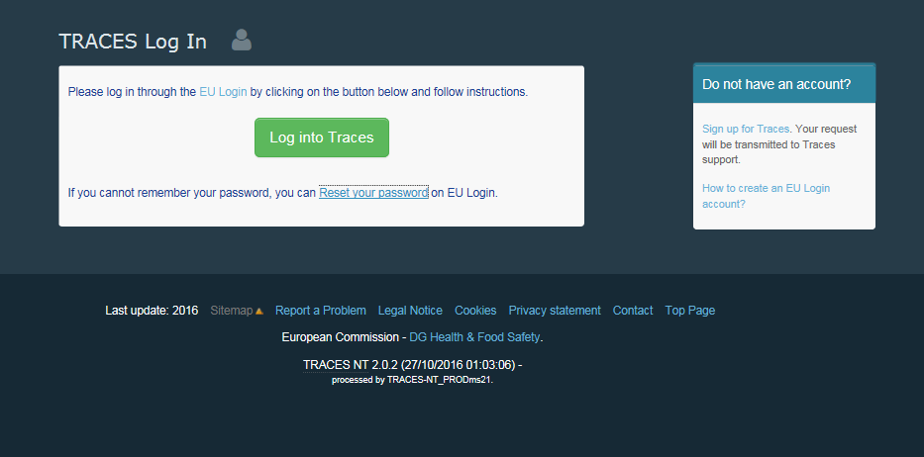

Please click on the link “sign up for TRACES”
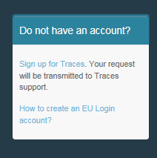

You now access the EU Login registration screen.
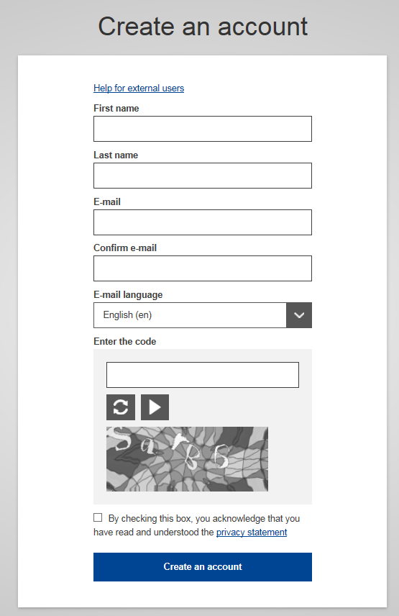

On the top right you can choose your language:

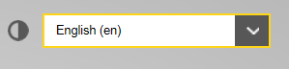

Complete all form fields: Username, First name, Last name, E-mail (you need to repeat the e-mail address in the next field to confirm the address), E-mail language and Code.
Please keep in mind that the data you choose in the screen above will be the data that appears in a certificate in TRACES NT, when you sign it. As the certificate in TRACES NT has a legal value, it is important that you open the EU Login account in the name of a REAL P, NOT your border control post, operator's name or control body!

For the E-mail Address: You are strongly advised to choose your individual professional email address which must be used to login to TNT-COI.

After completing all the fields, click on the "Create an account" button.

Once you have sent the request, an email will automatically be sent to you with a link to set your password. You have 90 min to click on the link (it will expire when the 90 minutes have passed).
If you do not receive this automatic email, you can find help on this page: https://webgate.ec.europa.eu/cas/contact.html

Please note that during the testing phase your request will not be automatically submitted to TRACES, you need to continue with the second step here below, once you have access to ECAS.

2) Second step, register in TRACES NT:

Please note: you need to follow step 2 on TRACES NT Production and on Training. When you request a role on one this is not automatically transferred to the other.

Return to the homepage of TRACES NT Production or Training (see links above)

Then click on the green button “Login into TRACES”, you will be redirected to the EU Login access. To log in you use the email address you selected when creating the EU Login Account:

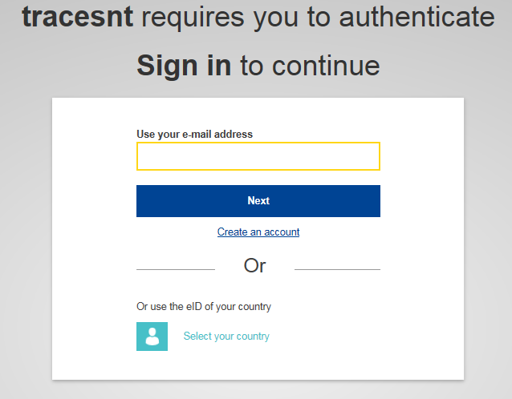

You are now redirected to the TRACES NT welcome page. Where you will find links to EU Login where you can change your EU Login credentials if need be or reset your password.
But more importantly, you need to select your role in TRACES. Please note that each individual can only take one kind of role.
You can be Operator (Importer, first consignee), Organic Control Body (or Control Authority) OR Authority (Border Control Post or Central Competent Authority). Within your role, you can take several posts. You can for example work for two or more different operators or as a control body control several countries etc.:
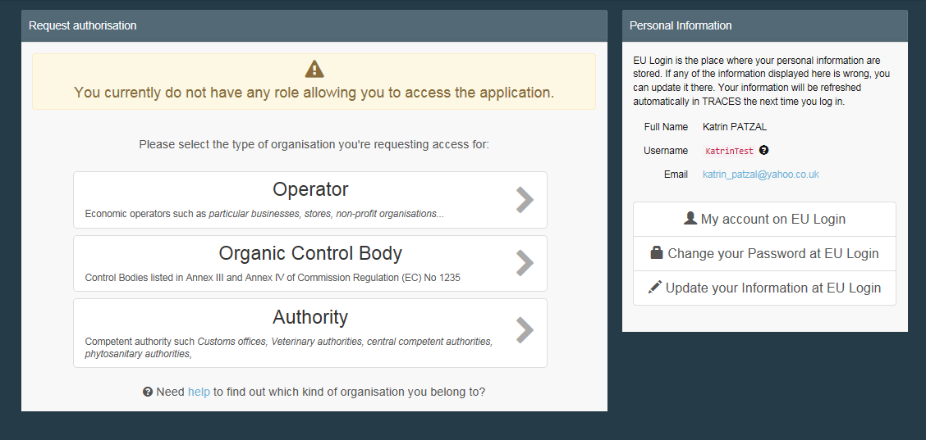

When you click on Operator:
You can search by country, Section, Activity type, name of the operator, etc. Tick the box behind the operator and then the 'Request Authorisation' button to submit the request.

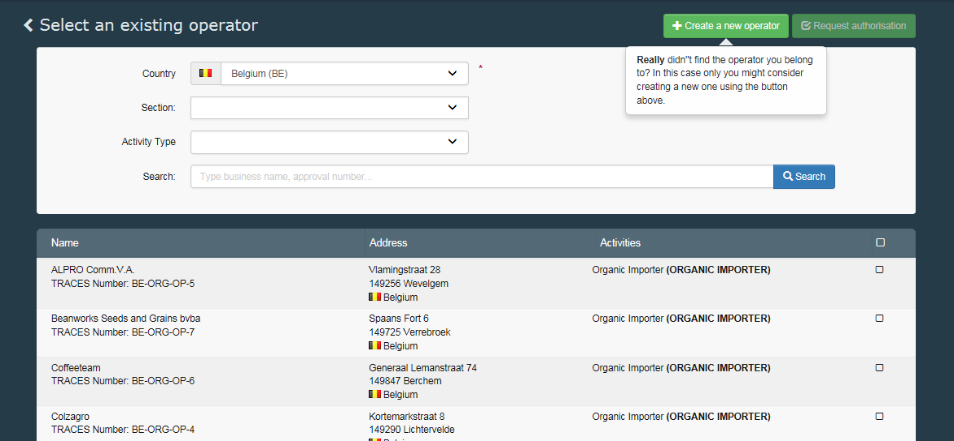

When you are sure that you can't find the operator you work for, you have the possibility to create it by clicking on the 'Create new Operator' button.
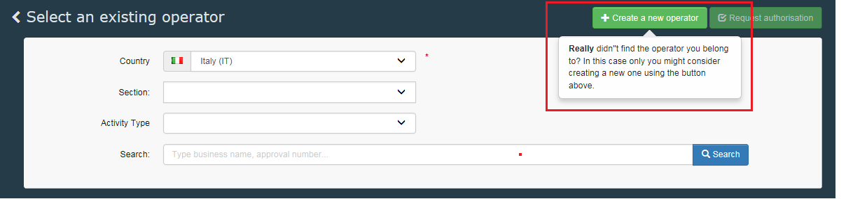

Complete all the information circled in red in the screen shot below (instead of the phone number you can also choose a fax, email or website) the information not circled is not mandatory, but you can provide it if you have it. The EORI number is currently only mandatory for organic importers:
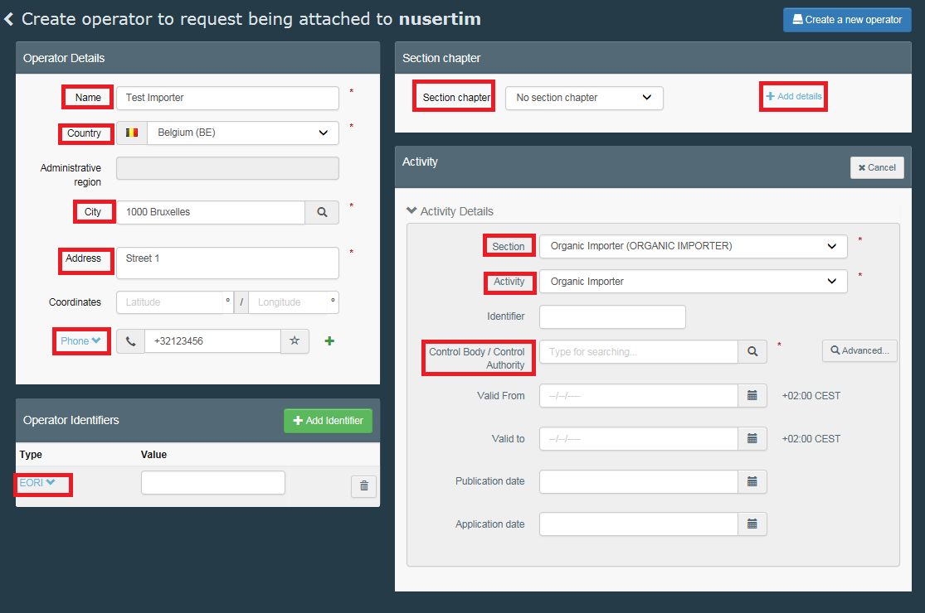
When all the information is complete, click on the 'create a new operator' button on top of the entry form:

Automatically the request for creating the new operator and your request to be joined to this operator are registered in the system.

When you click on Authority:
You can search by Country, role or name of the authority. Tick the box behind your Authority and click on the 'Request Authorisation' button to submit the request
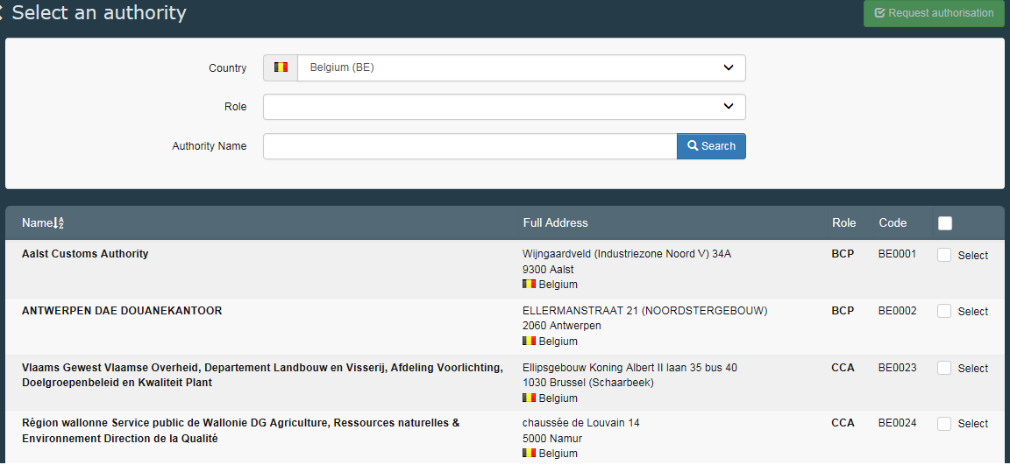

BCP: Border Control Post. Takes the role of Endorsing Authority for Organic Certification (EAOC – formerly CAFOP in TRACES NT)
CCA: Central Competent Authority: Organic Production and Labelling (OPL – formerly CAOPL in TRACES NT)

After selecting your role, click the request button on top of the page.

When you click on Organic Control Body:
You can search by country and the name of your control body.
When you are in charge of certifying for a single country, you can select that country by ticking the box behind it (1). If you are certifying for all the countries that your control body certifies, tick the tick box on top of the list (2) – see the screen shot below.

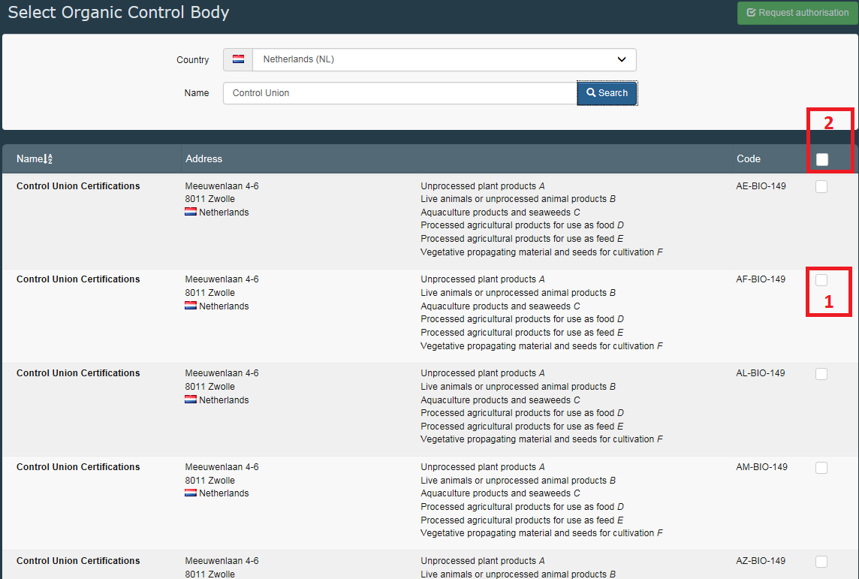

After selecting your role, click the request button on top of the page.

When you click the request button for any role, a window pops up:
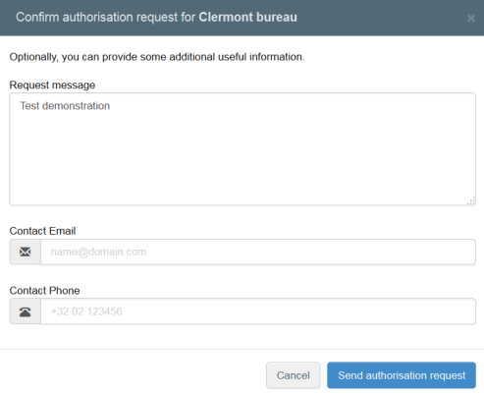
You can provide additional information, email and phone number. Please click on the “send authorisation request”
A green message will appear briefly and your request will be seen in your profile:

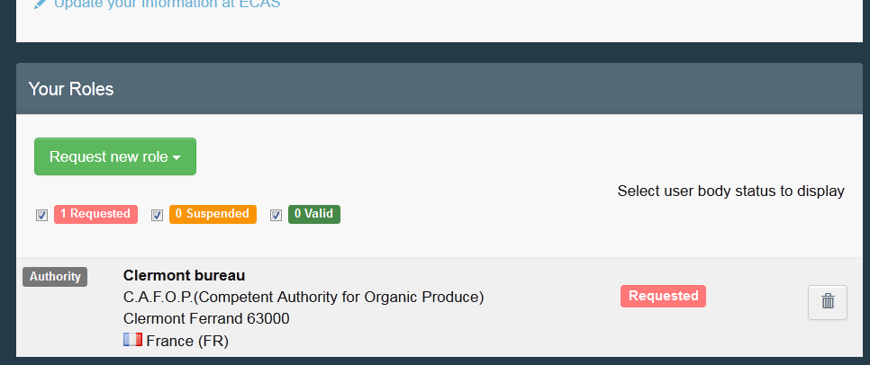

If need be, you can request additional new role(s).

On your profile page you can also set your preferences for time zone, notifications etc.
Then you can log out by clicking on log out in the top right corner of your browser.

If you are an operator or control body/authority, your National Authority or an Administrator inside your organization will manage (accept/reject) your request. If you are a National Authority, the Commission or an Administrator inside your organization will manage (accept/reject) your request.

Once you have followed the procedure, or if you have any questions, please send an email to our helpdesk: SANTE-TRACES@ec.europa.eu and AGRI-E-COI-ORGANIC@ec.europa.eu

Best regards,

The TNT-C.O.I. team.

